THERMO DENTAL FORMS
Patient’s Name: __________________________________________ Age: ________ Date: ________
Dental Chart with TCM Organ Associations

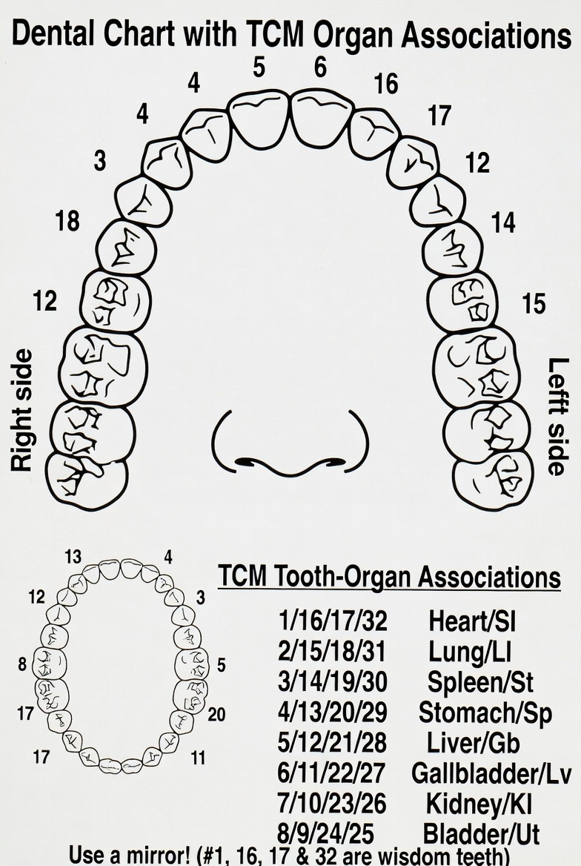
KEY (mark directly on the chart)
- Pulled teeth X
- Cavities filled ■
- Crowns ▲
- Bridge —
- Root canals ○
- Dentures? upper _____ lower _____
- Braces? upper _____ lower _____
- Retainer or Night Guard? upper _____ lower _____
TCM Tooth-Organ Associations (for holistic reference)
Upper Right (Patient’s Right) 1 (Heart/SI) 2 (Lung/LI) 3 (Liver/GB) 4 (Lung/LI) 5 (Kidney/BL) 6 (Kidney/BL) 7 (Heart/SI) 8 (Spleen/ST)
Upper Left (Patient’s Left) 9 (Spleen/ST) 10 (Heart/SI) 11 (Kidney/BL) 12 (Kidney/BL) 13 (Lung/LI) 14 (Liver/GB) 15 (Lung/LI) 16 (Heart/SI)
Lower Right (Patient’s Right) 32 (Heart/SI) 31 (Lung/LI) 30 (Liver/GB) 29 (Lung/LI) 28 (Kidney/BL) 27 (Kidney/BL) 26 (Heart/SI) 25 (Spleen/ST)
Lower Left (Patient’s Left) 24 (Spleen/ST) 23 (Heart/SI) 22 (Kidney/BL) 21 (Kidney/BL) 20 (Lung/LI) 19 (Liver/GB) 18 (Lung/LI) 17 (Heart/SI)
How to use this chart
- Print and mark teeth using the KEY.
- Refer to the TCM associations for holistic notes (e.g., during intake or treatment planning).
(Use a mirror! #1, 16, 17 & 32 are wisdom teeth)
- Use the numbered teeth in the chart above to indicate which teeth have had dental intervention. Also use the KEY to mark appropriately and answer upper/lower if needed.
KEY
Pulled teeth X Cavities filled ■ Crowns ▲ Bridge — Root canals ○Dentures? upper __ lower ___ Braces? upper ___lower ___ Retainer or Night Guard? upper ___lower ___
B. Write your chief complaint(s) below and indicate the approximate age of onset.
1. ____________________________Age ___ 4. ___________________________ Age ___
2. ____________________________Age ___ 5. ____________________________Age ___
3. ____________________________Age ___ 6. ____________________________Age ___

PERTINENT NEURAL THERAPY HISTORY
Typical childhood vaccinations? ☐ yes ☐ no Treated for parasites, infection? ☐ yes ☐ no
Please complete the following with the approximate age of occurrence:
Surgery ______________________________________________________________ Age ___
Serious Infections/Diseases (pneumonia, mono, T.B., cancer, heart attack, chronic bronchitis, colitis, mumps, measles, chicken pox, etc.) ___________________________________________________________________________ Age ___
Toxic Profession (past or present) ______________________________ Age ___
Dental Intervention (Root canals & extractions — refer to dental chart. Also age of first silver amalgam filling, braces, retainer, etc.) ______________________________________________________________________________________ Age ___
Injuries/Accidents WITHOUT stitches ____________________________________ Age ___
Injuries/Accidents WITH STITCHES/SCARS ______________________________ Age ___
Major Psychological Trauma ________________________________________________ Age ___
Long visits or lived in a foreign country (India, Mexico, Africa, etc.) ______________________________________________________________________________________ Age ___
Long periods on prescription or street drugs, or alcohol, or cigarettes ______________________________________________________________________________________ Age ___
Pregnancies/Births/Abortions/IUD’s, B.C. pills, etc. _____________________________________________________________________________________ Age ___
Medications/Allergies (past or present) __________________________________ Age ___
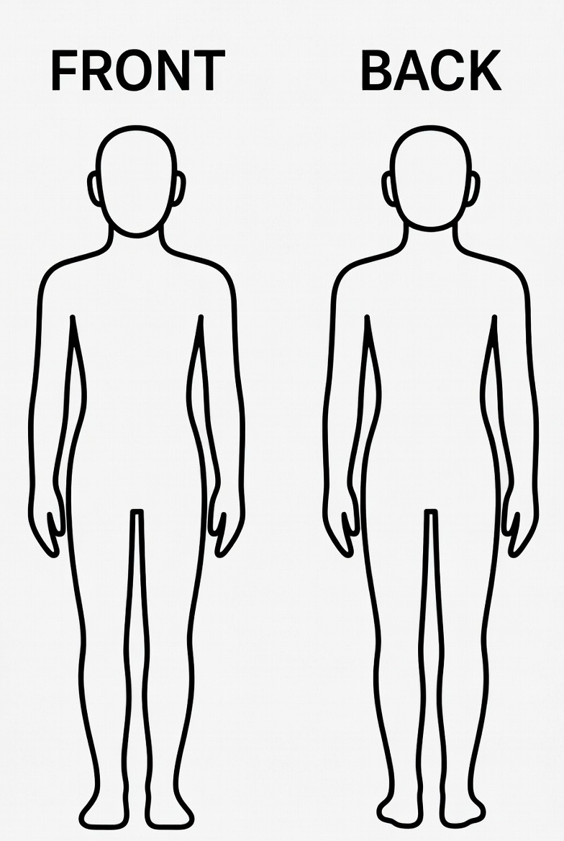
C. Finally, mark with an “X” where you have pain or dysfunction (on body outlines when printed).

